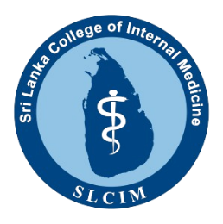

Sri Lanka College of Internal Medicine

SIMCON 2024 - 8th Annual Academic Conference

# Best Nurse Educator Award 2024

This award is for staff nurses who have done outstanding work to educate nurses and public related to NCD to improve clinical services in Sri Lanka.

The NCD project must have been completed between 1st April 2023 to 31st March 2024 and spearheaded and completed by the staff nurse.

The applicant must provide the following evidence:

* One A4 page summary of the project , Times New Roman with Font Size 11 and single spaced (use the format attached herewith).
* Pictorial evidence of the progression of the project as a presentation in PowerPoint format (Maximum 10 slides).
* Healthcare institutional (hospital) based - Letters from the Head of the Institution and the Matron/Nurse in-charge of the same institution where the project was carried out verifying the authenticity, service improvement and involvement of the applicant.
* Public health sector - Letters from the Head of the Public health Institution (MOH/RD) and the Matron/Nurse in-charge of the same institution where the project was carried out verifying the authenticity, service improvement and involvement of the applicant.
* Up to date CV of the applicant (Maximum 2 page).
* The shortlisted candidates will be asked to do a 5 minute presentation on Zoom platform.
* Submit soft copies of the summary, CV and presentation (ppt slides) and a cover letter to simcon@slcim.lk with **“Best Nurse Educator”** as the subject of the email.
* **Dead line: 21st September 2024**
* **This project/part of the project should not have been awarded by SLCIM or a similar organization previously. You may present in your preferred language (Sinhala/Tamil/English)**

**Best nurse educator award application – Summary form**

|  |  |
| --- | --- |
| 1.⁠ ⁠Title |  |
| 2.⁠ ⁠⁠objectives |  |
| 3.⁠ ⁠⁠project settings |  |
| 4.⁠ ⁠⁠methods of delivery/intervention |  |
| 5.⁠ ⁠⁠number of participants |  |
| 6.⁠ ⁠⁠outcome assessment (SMART criteria) |  |
| 7.⁠ ⁠⁠innovativity/  creativity |  |